**Level order traversal in spiral form:-**

Complete the function to print spiral order traversal of a tree. For below tree, function should print 1, 2, 3, 4, 5, 6, 7.  
  
  
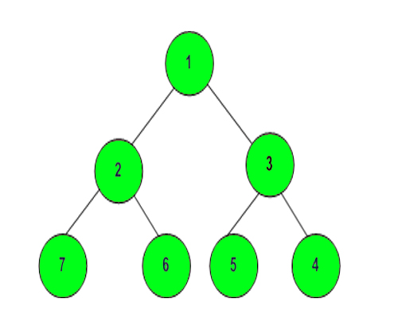

**Example 1:**

**Input:**

      1

   /   \

  3     2

**Output:**1 3 2

**Example 2:**

**Input:**

           10

        /     \

       20     30

     /    \

   40     60

**Output:** 10 20 30 60 40

**Your Task:**  
The task is to complete the function **printSpiral**() which prints the elements in spiral form of level order traversal. The newline is automatically appended by the driver code.  
**Expected Time Complexity:**O(N).  
**Expected Auxiliary Space:**O(N).

**Constraints:**  
0 <= Number of nodes <= 105  
1 <= Data of a node <= 105